Lab 7.2 Add a Node in Nagios Monitoring Tool

This section will show you how to add a node in Nagios Monitoring tool.

This lab has 2 sub-sections:

* + 1. Find the required plugin
    2. Install the plugin and check if it is working

**Please Note:** Make sure you have Nagios installed in order to proceed with this demo.

**Step 7.2.1:** Find the required plugin

Go to the root directory using the following command.

**sudo -i**

Create a downloads folder and download Nagios tar file in it.



Extract the file using the below command:

**tar -zxvf nagios-plugins-2.0.3.tar.gz**

Then, navigate to the downloaded folder.

**cd nagios-plugins-2.0.3**

**./configure --with-nagios-user=nagios --with-nagios-group=nagios**

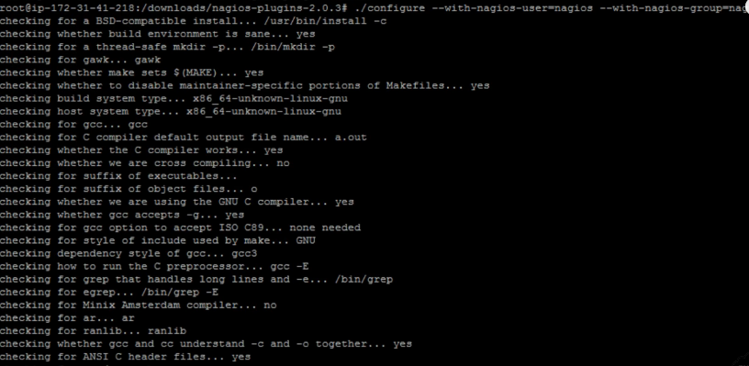

Compile and install the Nagios plugins using the commands below:

**make**

**make install**

**Step 7.2.2:** Install the plugin and check if it is working.

Restart the Nagios server using the command below:

**sudo service nagios restart**

Execute the command below to test Nagios|CMP plugin

**/usr/local/nagios/libexec/check_icmp 8.8.8.8**

The Nagios plugin has been installed successfully.

Open the browser and log in to your Nagios account.

Wait for 5 minutes and click on the services option to check if the plugins are working now.